Computer Language Coding Concepts

Access Controlling System Aspects in a Diagram
As said in the article Access Controlling System Aspects, there are various aspects of a command parameter you can access control.

In this article, access control over each aspect is expressed in a diagram. You can express whether an aspect is accessible.

Whether a parameter is an object or a command is also considered a parameter passing aspects, even though it is not access controlled.

Parameter passing can have the following elements

Object Get Private
Object Get Public
Object Set Private
Object Set Public
Class Get Private
Class Get Public
Class Set Private
Class Set Public
Value Get Private
Value Get Public
Value Set Private
Value Set Public
Clone X Get Private
Clone X Get Public
Clone X Set Private
Clone X Set Public
Data Get Private
Data Get Public
Data Set Private
Data Set Public
Execute Private
Execute Public
New Private
New Public
Annul Private
Annul Public
Object
Command

Now each element’s diagram expression is displayed.

Object Get Private | Object Get Public
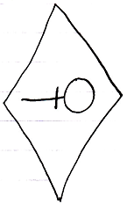 | 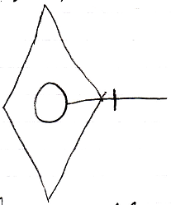
Object Set Private | Object Set Public
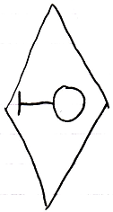 | 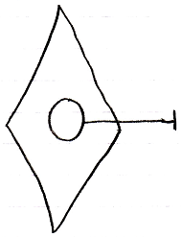

The line and the access symbol together form an access connector, to which you can attach sources or targets in order to fill in a reference.

Class Get Private | Class Get Public
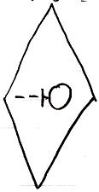 | 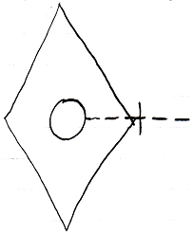
Class Set Private | Class Set Public
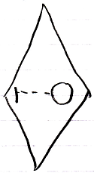 | 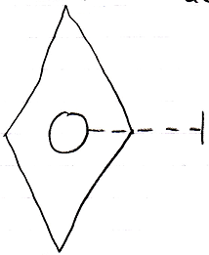
Value Get Private | Value Get Public
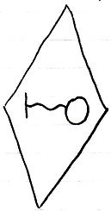 | 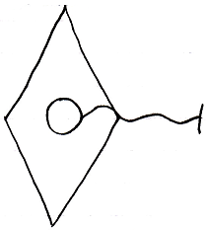

Note, that Value, Set and Get show opposite line direction compared to the Get and Set of other system aspects.

Value Set Private | Value Set Public
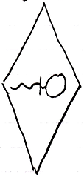 | 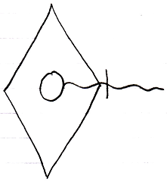

The diagrams below show access connectors for cloning at a depth of 2. That is just an example. Any cloning depth can be separately access controlled.

Clone 2 Get Private | Clone 2 Get Public
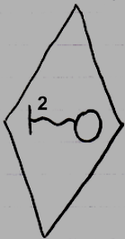 | 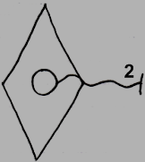
Clone 2 Set Private | Clone 2 Set Public
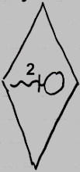 | 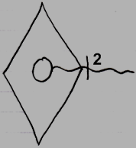

A preliminary notation for Data access, which is a term used for any kind of access to any sub-object, will be a double wavy line. But this notation may change in the future.

Data Get Private | Data Get Public
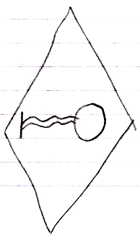 | 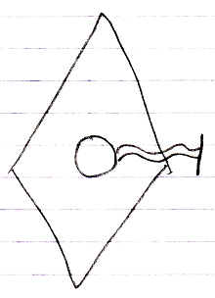
Data Set Private | Data Set Public
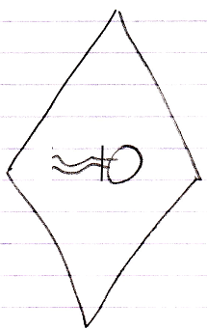 | 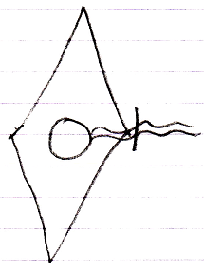

Execute Private | Execute Public
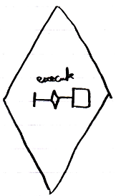 | 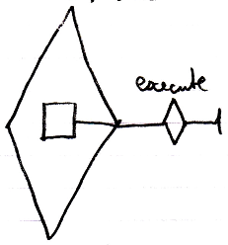

Execute is a system command. The exact notation of access control of a system command might change in the future.

New Private | New Public
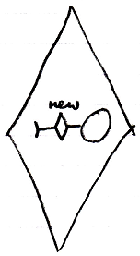 | 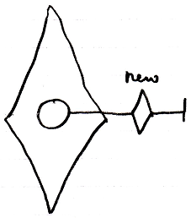
Annul Private | Annul Public
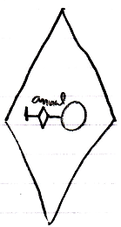 | 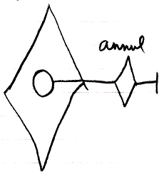
Object | Command
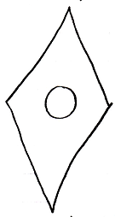 | 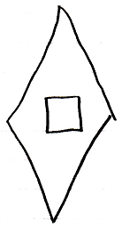

See also: Access Controlling System Aspects

Author & Copyright: Jan-Joost van Zon Date: September 17, 2008 – September 17, 2008 Location: Oosterhout, The Netherlands Status: Preliminarily finished

